

**Introduction to Database System**

**Fall 2024**

# **Midterm Lab**

# **VERSION I**

**Time Allowed: 1.5 hours**

**Instructions:**

1. **Understanding questions is part of the paper**. Therefore, no queries will be entertained during examination.
2. Bankschema.sql file is uploaded on teams/portal. Use those files to attempt the DML section of paper.
3. Use proper indentation/formatting while writing queries. Not properly indenting will deduct 5% marks.
4. **You need to make an MS Word with your name and registration should be mentioned on each page.**
5. **You need to write only queries with output as a screenshot in MS Word file, you need to write query (text form) + its output table (picture) if any.**
6. **You will solve the DDL + DML section only in word docx.**

# **Part 1 DDL** **[20 Marks]**

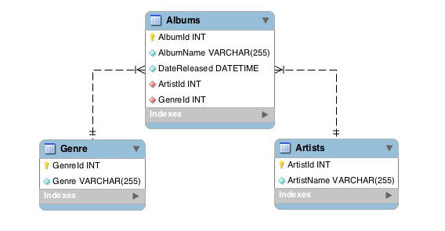

**Q1.** Implement the above tables with its attributes. Make Primary Key in both tables.

**Q2.** Insert at least 3 entries against each table.

**Q3.** Change the variable name of AlbumName to Name and datatype from varchar (255) to char in Albums table.

**Note: Do these in one Query only.**

**Q4.** Make a relation between **Artists** and **Albums**, **Genre** and **Artist** using alter command.

**Note:**  ArtistID in **Albums** table, should be foreign key from **Artists** table. GenreID in **Albums** table, should be foreign key from **Genre** table.

# **Part 2 DML** **[20 Marks]**

* **Import bankschema.sql schema.**

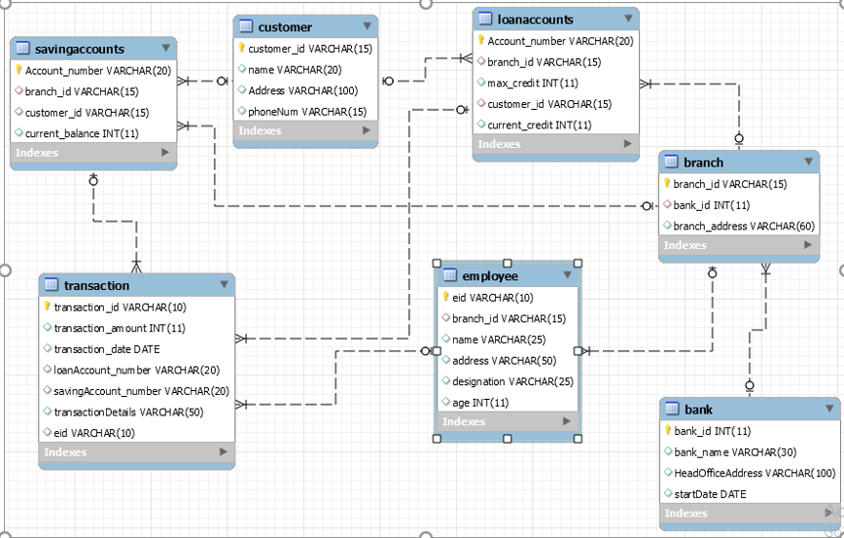

**Solve the following questions from the above schema**:  **(5+5+5+5)**

Q1. Write a query to show all the data of customers except for those with names "Imran Khan" and "Ahsan Ali", without using the <> and != operators.

Q2. Write a query to display the account numbers of all the savings accounts, ordered by their current balance in ascending order.

Q3. Write a query to display the information of employees whose names consist of exactly 6 characters and end with the letter 'n'.

Q4. Write a query to print the names of employees who have a transaction amount greater than 150000.

# **Part 3 ERD** **[10 Marks]**

**Draw ERD Diagram on ErdPlus.**

UPS prides itself on having up-to-date information on the processing and current location of each shipped item. To do this, UPS relies on a company-wide information system. Shipped items are the heart of the UPS product tracking information system. Shipped items can be characterized by item number (unique), weight, dimensions, insurance amount, destination, and final delivery date. Shipped items are received into the UPS system at a single retail center. Retail centers are characterized by their type, uniqueID, and address. Shipped items make their way to their destination via one or more standard UPS transportation events (i.e., flights, truck deliveries). These transportation events are characterized by a unique scheduleNumber, a type (e.g, flight, truck), and a deliveryRoute.

Please create an Entity Relationship diagram that captures this information about the UPS system. Be certain to indicate identifiers and cardinality constraints.